**Project Report  
  
 Online Voting System   
  
  
Group Members :  
  
1: MUHAMMAD MUSA KIANI (04162214025)**

**2: AJMAL KHAN (04162214014)**

**BSIT 4TH EVENING (Spring 2024)**

**DATABASE SYSTEMS  
  
Submitted To: Dr. Adeel Anjum  
  
Submitted Date: 12/7/2024**

**Quaid-i-Azam University Islamabad**

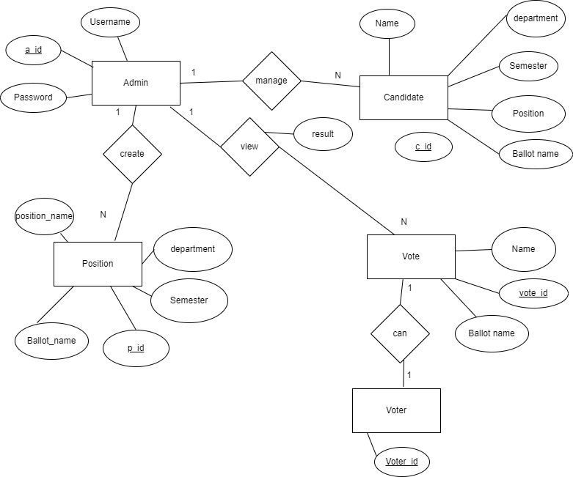

**ERD Diagram of Online Voting System**

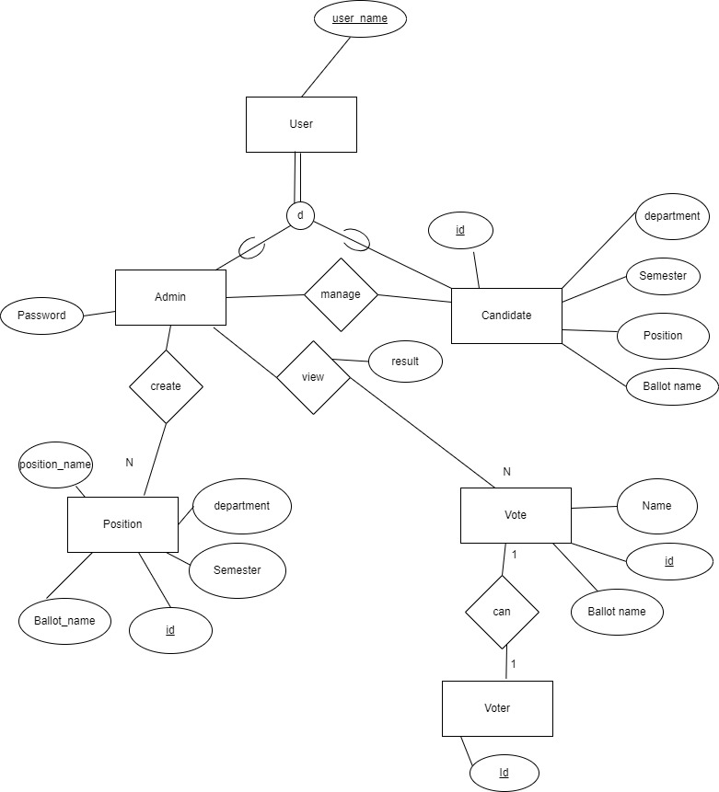

**EERD Diagram of Online Voting System**

**Relational Table:**

**Admin**

|  |  |  |
| --- | --- | --- |
| **Username** | **password** | **a_id** |
|  |  |  |

**Candidate:**

|  |  |  |  |  |  |  |  |
| --- | --- | --- | --- | --- | --- | --- | --- |
| **Name** | **c_id** | **semester** | **department** | **position** | **Ballot_name** | **a_id** | |
|  |  |  |  |  |  |  |

**Vote**

|  |  |  |  |
| --- | --- | --- | --- |
| **Name** | **Vote_id** | **Ballot_name** | **a_id** |
|  |  |  |  |

**Voter**

|  |  |
| --- | --- |
| **Voter_id** | **Vote_id** |
|  |  |

**Position**

|  |  |  |  |  |  |
| --- | --- | --- | --- | --- | --- |
| **Position_name** | **p_id** | **Department** | **Semester** | **Ballot_name** | **a_id** |
|  |  |  |  |  |  |